BEN331-CR331
Biomedical Signal Processing Team Projects

Overview
Here is a list of possible project topics:
- ECG Analysis/Denoising using Wavelets: Teach us about wavelet decomposition and apply it to “denoising” example ECG data to make it easier for human diagnosis. Note there are downloadable Wavelet toolboxes available for MatLab, Octave and Scilab.
  - Alex Baker
  - Nick Jensen
  - Chris Quinn
- Separation of Fetal ECG from Maternal ECG to accurately read Fetal ECG given Abdominal ECG and Classical ECG
- Ultrasonic Imaging in 3-D: Teach as about the processing of ultrasonic signals to provide 2-D images and use available 2-D data to develop 3-D images.
  - Natalia Velasquez Jurado
- Tomographic Image processing (Catscan, MRI): Teach us about Tomography and its application in processing biomedical images.
- Electromyography (EMC) signals and processing them to improve the signal to noise ratio.
  - Amy Caplan
  - Ronald Chasse
  - Peter Coffman
- Brain Signal (EEG) Analysis
  - Liliana Delmonico
  - Andrew Jobson
  - Ashley Halmans
- Others?
  - Robert ODonovan
Teams will need test data, much of which is available in public domain databases. There is also instrumentation to capture a variety of Biodata signals that is used in our Instrumentation course which is running this semester. Contact Dr. Freudzon (sfreudzon@fairfield.edu) to access and use the instrumentation.

Team Membership
Each team should be composed of students with a variety of backgrounds/skills so that the overall team can span the problem that their project will present. I expect that teams will each have 2-3 students.

Background Topic Discussion

Wavelets
One of the problems with Fourier analysis is that the math assumes that the signal is stationary for all time. Most of the time we can’t wait that long to do the analysis so we operate on a time window of the signal to represent the signal over all time. This introduces some artifacts in our results.
Wavelets decomposition is an alternative analytical method that deals explicitly with time and frequency simultaneously. You define a basis wavelet (e.g. “Mexican Hat”):
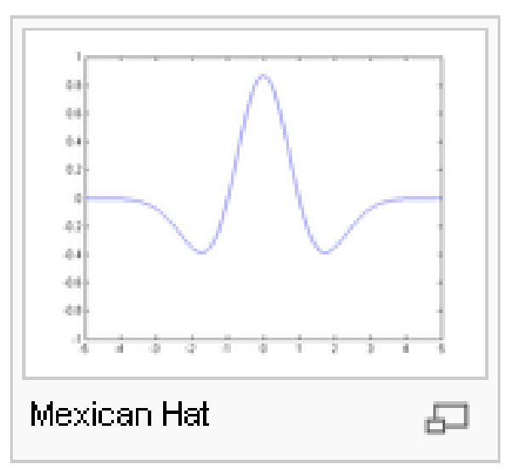
And you time shift this basis wavelet over the interval that your data exists and find a set of correlations. Then you stretch the wavelet and do the correlations again. Repeat until the wavelet length equals the data length. This forms a decomposition of your signal in time and something akin to wavelength. See wavelets by Turkel (2001)

Ultrasound
This involves transmitting small pulses of ultrasound echo from a transducer into the body. As the ultrasound waves penetrate body tissues of different acoustic impedances along the path of transmission, some are reflected back to the transducer (echo signals) and some continue to penetrate deeper. Now the problem is how to construct an image from the reflected signals.

Tomography
Here a beam (x-ray, electron, proton) is passed through a specimen and detected on the other side. This is repeated in a two dimensional scan (presently rotation and translation) over the specimen and an image is determined in slices (in the translation direction) .

Electromyography
“Electromyography (EMG), the recording of electrical activity in muscle, should be regarded as an extension of the clinical examination. It can distinguish myopathic from neurogenic muscle wasting and weakness. It can detect abnormalities such as chronic denervation or fasciculations in clinically normal muscle. It can, by determining the distribution of neurogenic abnormalities, differentiate focal nerve, plexus, or radicular pathology; and it can provide supportive evidence of the pathophysiology of peripheral neuropathy, either axonal degeneration or demyelination. EMG is an obligatory investigation in motor neurone disease to demonstrate the widespread denervation and fasciculation required for secure diagnosis.” Kerry R Mills, 2005 Journal of Neurology Neurosurgery and Psychiatry

