# Biomedical Instrumentation

## Introduction

Biomedical signals are weak (measured in millivolts where 1 volt equals 1000 millivolts). However, any computer used to analyze these low-level signals requires an input signal of a few tenths of a volt to a few volts. So, weak signals can be lost in low-level noise. Simultaneously, there are always high-level interfering signals that must be ignored or filtered out. The process of preparing signals for processing in a computer is called Signal Conditioning.

Hence, this chapter will focus on topics that are relevant to Signal Conditioning:

* Differential signals, Common Mode signals, and the Common Mode Rejection Ratio
* Operational amplifiers
* The Instrumentation amplifier
* Active filters

Where possible, the discussion will first provide understanding of why things work and then present some math to quantify how well they work.

## Differential signals vs Common Mode signals

### 2-1. Voltage measurement

Voltage is a potential difference between two locations. It is stated as a voltage with respect to ground so that voltages at various points can be compared to each other.



In the simple resistor circuit above:

* The voltage at **Node A** with respect to (WRT) **Ground** is the battery voltage.
* The voltage at **Node B** with respect to **Ground** is just the voltage across resistor **Rb** (or according to Ohm’s Law the current through Rb times its resistance).
* The voltage across **Ra** is the voltage WRT **Ground** at **Node A** minus the voltage WRT **Ground** at **Node B** or the Differential voltage is obtained by connecting a voltmeter directly across **Ra**.  
    
  Note: The positive side of the voltage across the resistor is where the current enters the resistor.

### 2-2. Differential Voltage

We define a differential source with Vs on the positive lead and minus Vs on the negative lead. With this definition the differential signal is twice Vs since it is Vs – (-Vs) = 2*Vs. That is, the differential voltage is:

Vs = [(V+) – (V-)] / 2.

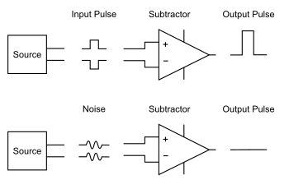

### 2-3. Common Mode Voltage

By analogy we define the Common Mode voltage as Vc = [(V+) + (V-)] / 2. This Common Mode voltage in a differential system is usually noise from external sources that is picked up equally by both leads carrying the differential signal. Therefore, a perfect subtractor can virtually eliminate this source of noise in a differential system:



### 2-4. Common Mode Rejection Ratio (CMRR)

Nothing is perfect in the real world. We will define a measure of the effectiveness of using differential systems as the ratio between the actual Common Mode signal voltage and the amount of this signal that leaks into the differential measurement. This ratio is often a very large number (the larger, the better). So, for convenience we use the logarithmic measure, Decibels (dB), calculated as 20*log10(V1/V2).

Thus, if the common mode signal is 1 volt and the amount of this signal seen in the differential measurement is 1 microvolt, then the CMRR is 1 million or 20*log10(106) = 20*6 = 120 dB.

In this example, if the desired differential signal is 1 millivolt there is a Signal to Noise Ratio (SNR) of 1000 (103) which is also stated as a CMRR of 60 dB.

### 3-1. The Operational Amplifier (OpAmp)

Today, integrated circuit (IC) Operational Amplifiers are available at low cost with high performance. This era began with the production of the µA741 in 1967. An OpAmp has the following characteristics:

* Very high voltage gain (>100000, 105)
* The differential inputs do not pull appreciable current from the source (high input impedance).
* The output impedance is very low (it can drive heavy loads without problems).
* High common mode rejection (if neither input approaches either supply voltage).
* Linear response (low signal distortion if none of the input/output signals gets close to the supply voltages).

OpAmps are very useful because they can:

* provide gain,
* drive low resistance loads
* add/subtract signals, and
* filter signals to remove unwanted signals (noise)

### 3-2. Basic OpAmp Configurations

When utilizing an OpAmp, feedback is required to reduce any flaws in its performance. This feedback:

* reduces the gain to maintain stability,
* significantly increases the frequency response, and
* reduces any distortion in the output signal.

### 3-2-1. The Inverting OpAmp

The inverting OpAmp is:



where R1 is the “feedback” resistor and R2 is the “input” resistor.

Using nodal circuit analysis, it can be shown that the gain is:

A= - (R1/ R2)

The nodal analysis uses two facts:

* Since the gain of the raw OpAmp is very high, V- must equal V+ or Vout will immediately jump to one of the power supply rails (not shown in the circuit above).
* Since the inputs pull no current, the current through the two resistors is the same.

The other fact that comes out of this analysis is that the input impedance equals R2, which is not desireable.

### 3-2-2. The Non-Inverting OpAmp

The non-inverting OpAmp is:



Where R1 again is the “feedback” resistor and R2 is the “input” resistor. However, here the input signal is applied to the positive OpAmp input, and the source resistor is connected to ground. Using nodal circuit analysis it can now be shown that the gain is:

A= 1 + (R1/ R2).

The nodal analysis uses the same two facts as above, but here the input impedance remains high.

A useful varation of the Non-Inverting OpAmp is the Unity Gain Buffer where R2 is an open circuit and R1 is a short cicuit yielding a gain of 1.



### 3-2-3. A Balanced Differential Amplifier

An OpAmp can be configured as a Balanced Differential Amplifier as shown in the circuit below:

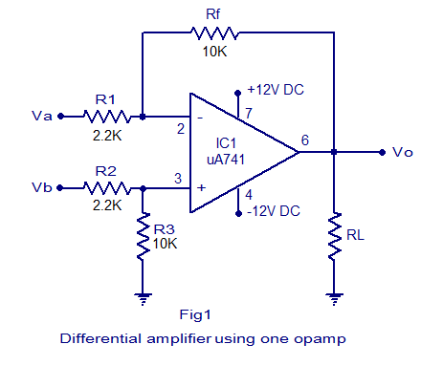

Deriving the differential gain of this circuit is somewhat more complex than the derivations for the earlier circuits. One way is to first set Vb to zero and calculate the output due to Va, then repeat for Vb by setting Va to zero to get the output due to Vb. Then subtract the two outputs (Superposition) to get the differential gain (Ad) which is:

Ad = Vo / [(Va - Vb) / 2] = Rf / R1

which is 10K/2.2K or 2.5454 for the example above.

Note the symmetry in the example above:

R1= R2 and Rf = R3

which is required to maintain a high CMRR.

And the Common Mode Gain:

Acm = 2 * Vo / [ (Va + Vb) / 2] = 0

since the two results used to calculate the Differential Gain above are equal and opposite.

The only limitation in this configuration is that the input impedance (as in the Inverting Amplifier), is a low input impedance (2.2K ohms in this example). This limitation is corrected in the Instrumentation Amplifier that is described in the following section.

### 3-2-4. The Instrumentation Amplifier

Fixing the input impedance problem in the Differential Amplifier above is surprisingly easy. Just precede each input with a Non-Inverting Amplifier stage while making sure to maintain high CMRR by maintaining the symmetry discussed above.



OpAmps U1 and U2 are the Inverting Amplifiers and U3 is set up as a Differential Amplifier as noted above. For a high CMRR; R1=R2, R3=R4, R5=R6, and R7=R8. The overall differential gain is the gain of the input OpAms times the gain of the Differential Amplifier or:

Ad = [ 1 + ( R3,4 / R1,2 ) ] * ( R7,8 / R5.6 )

Note: It is difficult to obtain so many matched resistor pairs if the circuit is built out of discrete components. If the whole configuration is created as a single integrated circuit, matched components are easily obtained.

One last problem remains in this configuration: U1 and U2 each sees and amplifies the common mode signal. This significantly limits the magnitude of the common mode signal that can be handled without exceeding a power supply voltage. Surprisingly, just removing the ground connection between R1 and R2 eliminates the amplification of the common mode signal by the two input Operational Amplifiers. This happens because the point that was grounded now shifts to the common mode voltage, and each input Operational Amplifier sees only the difference between its input and the common mode voltage.

## Filters

### 4-1. What is frequency?

To discuss filters, one must understand the concept of frequency. Frequency is a measure of how rapidly a signal varies with time. Most signals of interest vary with time. Therefore, they have energy at many frequencies. If a signal is constant over time, we call it Direct Current (DC) which has a frequency of zero. A signal that has all its energy at only one non-zero frequency is a sinusoid:

V(t) = A * sin(2*π*f*t + ϴ) where ϴ is in radians, not degrees

Cosine (in blue) and Sine (in red) signals are displayed below. Note that time = 0 is a vertical line in the middle of this graph.

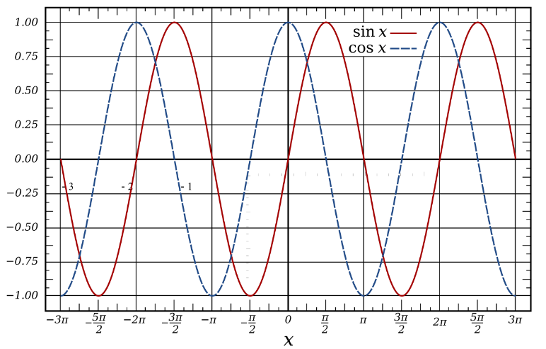

A sine wave is defined by three parameters:

1. Amplitude (A) – the peak value of the sinusoid (happens when the total within the parenthesis is a multiple of 360° or 2π radians for cosine or that plus 90° or π/2 radians in the case of a sine wave). The graph above shows the amplitudes of both as unity as noted in the vertical axis.
2. Frequency (f in Hertz, cycles/second, or ω = 2πf in radians/second) – how rapidly the sinusoid goes through its cycles. An alternate parameter is the period (T = 1/f) which is how much time it takes for one full cycle of the sinusoid.
3. Phase (θ) – A shifting of the timing of the sinusoid.   
   Notes:
   1. sin(x + 90°) = cos(x)
   2. You can measure the phase by comparing the sinusoid to a reference sinusoid and determining the offset of a zero crossing as a percent of a full period   
      (T = 1 millisecond for f = 1000 Hertz). Then just apply that fraction of a cycle to either 360° or 2π radians to get the phase shift between the two sinusoids.

A periodic signal, one that repeats with period “T”, can be accurately represented as a sum of these sinusoids (a Fourier Series representation). Therefore, a periodic signal has energy at many frequencies, each of which is a multiple of the fundamental frequency: f0 = 1/T.

### 4-2. What is a Filter?

An electronic filter is designed to discriminate between energies at different frequencies by attenuating some and amplifying others. This section introduces the three passive components that can be used to build filters, two of which respond differently at different frequencies:

* Resistor – treats all signals identically, independent of the signal’s frequency. You can think of a resistor as a restriction in the flow of electrical current when a voltage is applied. Resistors obey Ohm’s Law:

V = I * R

Where V is the voltage in volts, I is the current in amps, and resistance is measured in ohms.

* Capacitor – The magnitude of a capacitor’s impedance varies inversely with frequency. An ideal capacitor behaves like an open circuit at DC (zero frequency) and like a short circuit at very high frequencies. You can think of a capacitor as a bucket filling up with electrical charge (in Coulombs) as current flows into it. The capacitor’s equations are:
  + v(t) = (1/C)*∫i(t)dt or equivalently
  + i(t) = C*dv/dt

Energy is stored in a capacitor as an electric field and capacitance is measured in “Farads”.

* Inductor – An inductor is just a coil of wire (sometimes wrapped around a magnetic core). The magnitude of its impedance is proportional to frequency. An ideal inductor behaves like a short circuit at DC and like an open circuit at very high frequencies. One way to think about an inductor is that it adds inertia to the flow of current. The inductor equations are the “dual” of the capacitor equations:
  + i(t) = (1/L)*∫v(t)dt or equivalently
  + v(t) = L*di/dt

Energy is stored in an inductor as a magnetic field and inductance is measured in “Henrys”.

### 4-2-1. A Passive Low Pass Filter

The circuit below is a simple, Passive Low-Pass filter.

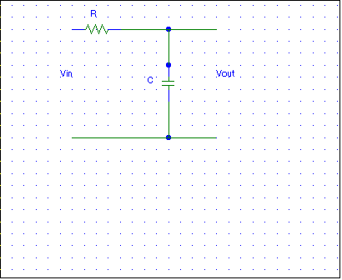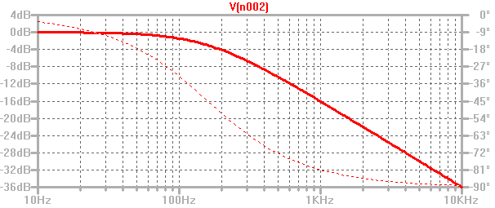

The plot on the right is called a “Bode” plot. It shows the frequency response   
(Attenuation vs frequency – a solid red line) and the phase shift vs frequency (a dotted red line) that occurs as the capacitor impedance dominates over the resistance. The plot was drawn using LTspice for a 10kΩ resistor and a 0.1 µF capacitor.

Note: If you calculate the “RC Time Constant” (0.001 seconds in this case) you can determine the frequency where the magnitudes of the resistance and capacitor impedance are equal:

ω = 1/RC = 1000 radians/sec or f = 159.2 Hz

Where the Atteuation is 3 dB and the phase shift is 45°.

You can graphically find the same frequency by extending the horizontal line at low frequencies and the -6 dB per “octave” (a factor of two in frequency) slope at high frequencies, they intesect at the frequency determined by the time constant.

### 4-2-2. Calculating the Output vs. Time for the Passive Low-Pass Filter

Consider the simple low pass filter discussed above.



The output as a function of time due to an input signal can be derived using circuit analysis and differential equations.

The Kirchhoff loop equation for this circuit is:



First solve the Homogeneous Equation to get the “Homogeneous” or “Natural” solution:



Differentiating both sides of the equation and multiplying by C



The solution to this equation is of the form  and substituting:





Simplifying,

 or a = 1/RC

Note: RC is the Time Constant

The **Homogeneous, or Natural,** solution is therefore:



But since the voltage across the capacitor starts at 0 and,





But we want the voltage out which is:



Substituting,



where k is the constant of integration

Now we need to find the **Particular Solution** that is due to the **Forcing Function** (input) which, for this analysis is a sudden step voltage that changes from 0 to 1 at t=0.

Case 1 (t < 0): obviously, the output is again zero.

Case 2 (0 < t < ∞)

We have that the original input is a constant “” which was differentiated and became 0.

The output needs to be of the form



Substituting into our original differential equation:



Or,



Since this must be true for all 0 < t < 1, B = 0 (from the t term) and from the constant term

A also is 0 so



Therefore, the total solution is



but this must be zero at t = 0



Solving for k yields k = Vin and we have the output voltage:

 for 0 < t < 1

This output signal (red) and the driving input signal (blue) are graphed below for a time constant of one msec.

Vin(t) _____

Vout(t) _____



Thus, the effect of filtering the input signal with a low pass filter is to slow down the signal’s rate of change. This corresponds to the reduction of the energy at higher frequencies by the low pass filter.

### 4-2-3. RC Low-Pass Filter AC analysis (Via an LTspice simulation)

Amplitude slope at high frequency is asymptotically

-6 dB /octave or -20 dB / decade

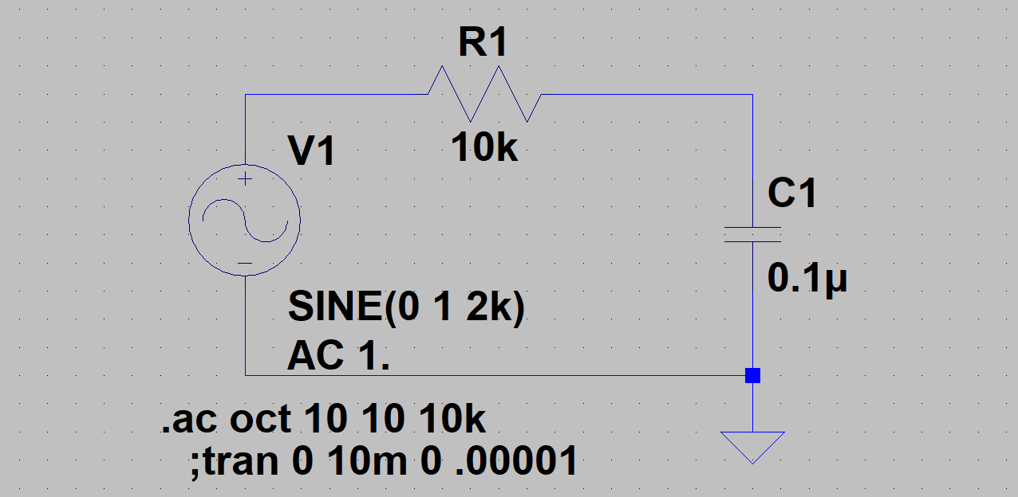

Simulated RC – Frequency sweep from 10 Hz to 10 kHz

Vc Amplitude and Phase plotted (log-log graph)

Note: Decibels are a logarithmic measure of voltage ratios dB = 20*log10(VC/V1) in this case.   
(6 db is a factor of 2, 3 dB is the “half power point”)

Analysis:

V1 = 1*sin(2πft) = 1 at 0°, find VC

°



Our current is therefore

so



and



This is at the “half power point” (when the magnitudes of the real and imaginary parts are equal) or

2πf = 1/RC

Remember that RC is the “Time Constant” and the frequency at the half power point is:

and the phase at that frequency is 45°



### 4-2-4. Active Filters

When designing complex filters, it is more effective to use Active Filters instead of Passive Filters because they are easier to implement. Active filters are based on using the Inverting or the Non-Inverting OpAmp configurations that were discussed earlier in this chapter. We just need to consider replacing one or both of the gain determining resistors with simple RC series or parallel circuits (Inductors can also be used, but they tend to be more expensive and are difficult to implement using integrated circuit technology).

An example of an Active Low Pass filter that is equivalent to the Passive Low Pass filter discussed earlier is:



Now the gain, A, is:

A = - (Rin/ Zf).

Where Zf is the complex impedance of Cf in parallel with Rf.

Note that as the frequency rises, the feedback impedance will decrease due to the decreasing impedance of the capacitor with increasing frequency. Hence the gain will also decrease at this rate with increasing frequency.

Higher performance active filters can be built replacing both branches with RC combinations creating “Second Order” Active Filters and these can be concatenated to produce even higher order filters.

### 4-3. Cleaning Signals with Filters

Signals are often corrupted by interfering signals, which makes analysis or interpretation of the signal difficult. Here is an example of an unfiltered EKG signal:

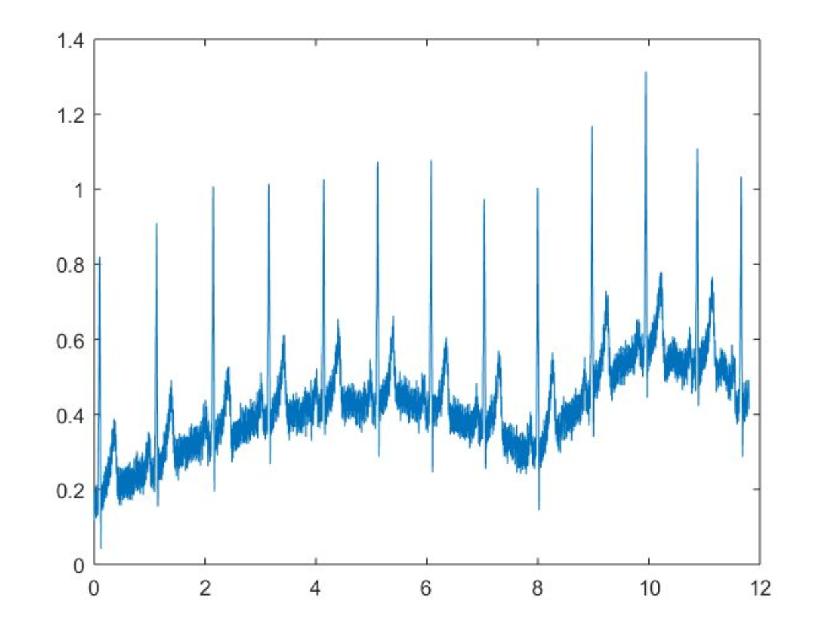

There are two distinct problems in this signal:

1. The first is the low frequency variation in the signal baseline, most likely caused by patient breathing.
2. The second problem is additive noise from an external source (the reference EKG lead was disconnected, which removed the Common Mode Rejection attenuation built into the differential instrumentation).

Below is the same signal passed through a High Pass filter to remove the baseline variation and then a Low

Pass filter to remove most of the additive noise.

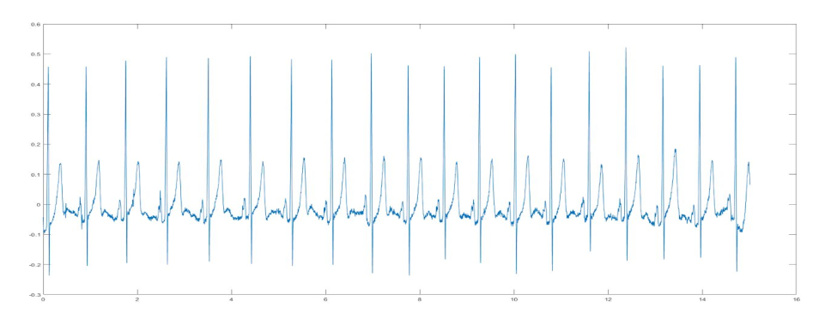

It is apparent that this result is far easier for the physician to interpret.

It should be noted that these results were obtained using Matlab on the captured EKG signal. Hence, the filters were implemented as Digital filters. Digital filters are discussed in a separate chapter.