Laboratory 2.4 – The Instrumentation Amplifier
(Note: the section and page references here do not directly point to the correct page of your text as they reference an earlier edition text)

What is an Instrumentation Amplifier?
This is a very useful, three OpAmp design that has a differential pair of inputs with:
- A high input impedance (The two non-inverting OpAmps have a high input impedance)
- Good and stable differential gain (The output due to the difference between the two inputs)
- A very high Common Mode Rejection ratio (CMRR)
  - The CMRR is the ratio in dB between the differential gain (the second stage OpAmp does the differencing) and:
  - The common mode gain (the output due to the sum of the two inputs divided by 2
  - The common Mode signal is usually an external disturbance that is undesirable signal.
- Low distortion, due to the use of feedback
You are asked to choose some resistor values to set the gains of the circuit and the differential gain. The remote member of the team will simulate the circuit while the “hands-on” member builds and tests the circuit. Make sure to measure the actual resistor values used so the performance of simulated circuit and the circuit as built can be compared.
Download the specification sheet for the 741 OpAmp to see both the pinout diagram (remember to power all three OpAmps with +15 and – 15 volts on the correct pins) and its expected performance (gain, input/output impedances, and offset voltages/currents).
Make a point of also unbalancing the circuit a bit (as mentioned in the last paragraph of the Lab) to see the effect on the Common Mode Rejection Ratio (CMRR). Measuring the CMRR is easily done in your simulation, If time allows, also try measuring the CMRR in your circuit as built.
Your full Lab report should be uploaded to Blackboard by the next lab session. Do not fall behind as it becomes difficult to catch up later in the semester and I will be penalizing teams that submit reports late. These labs are a good opportunity to learn so do not be afraid to experiment with your circuit. ASK QUESTIONS! As they arise via Quip. You can direct questions to @jdenenberg or better @everyone to get responses from your instructor, your TA, or others in your cohort of 16 students in our lab course.
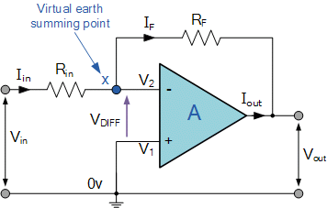
How Do I Calculate OpAmp Gain? (You did this in EE213!)
Let us look at an “inverting operational amplifier”
(Not the ones in the first stage of the Instrumentation Amplifier)
There are basic rules for an OpAmp:
- The input impedance is very high.
- The output impedance is very low.
- The gain is ridiculously high

Since the gain is so high, the voltages V₁ and V₂ must be virtually identical since a small difference would cause the output to go to one of the power rails (they are not shown here, but the OpAmp chip requires +V and -V supplies). Since V₁ (the positive input) is grounded, V₂ becomes a “virtual ground” (due to feedback) as denoted.
Now just write a “Node Equation” at node x:
I_{in} = I_{f} or V_{in}/R_{in} = - V_{out}/R_{f} or
Gain = V_{out}/V_{in} = - R_{f}/R_{in}
I never memorize equations. I just remember the basics and easily re-derive the needed equation since I cannot rely on my memory to get everything right. It is easy to forget the assumptions that were made to derive the equations in your Text, so using equations often results in wrong answers.
I expect to see a derivation of the gain equation for each of the two OpAmp configurations in your Instrumentation Amplifier Laboratory Report.
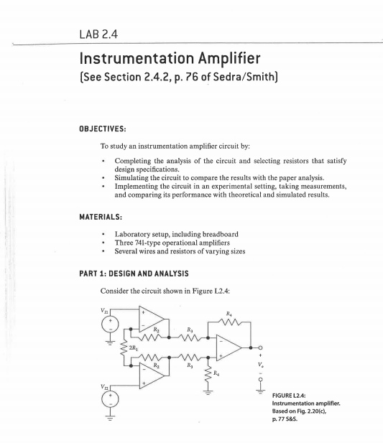
Note that the 2*R1 resistor is just two R1 resistors in series, each acts as the input resistor for its respective OpAmp and the point in the middle is another "Virtual Ground" that shifts along with the Common Mode Signal as it equals the average of the two inputs to the Instrumentation Amplifier. Actually, grounding this center point causes the input OpAmps to saturate if there is a significant Common Mode signal.
