Lab 4.1 – Diode I-V Transfer Curve
A diode is a “one-way valve” it has a PN silicon junction (N materials have excess electrons that can move through the crystal structure and P materials have “holes” or missing electrons in the crystal which again allows current flow ). When the diode is reverse biased (plus on the N or cathode -which is the striped end and minus on the P or anode), there is no current flow as the boundary carriers are swept away and a “depletion region” forms at the boundary blocking current flow. When you forward bias the diode (Positive at the P and Negative at the N) by more than a threshold voltage (about 0.7 volts for silicon) the current will increase rapidly as the voltage across the diode increases (this results in a very low small signal resistance at forward conducting operating points).
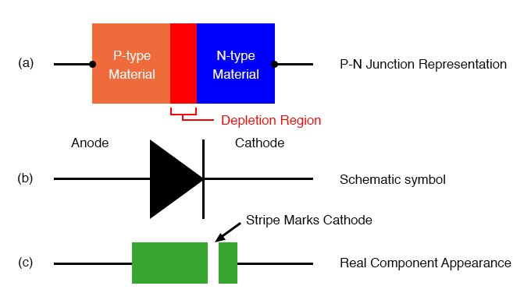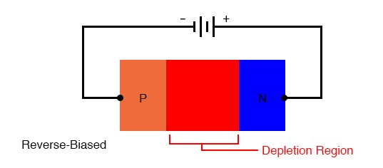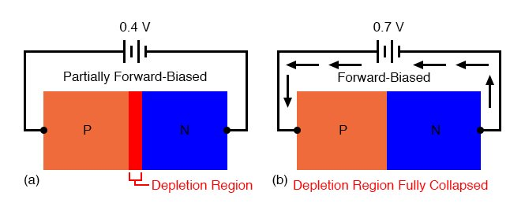
In this “Diode I-V Transfer Curve” lab we will measure the current through a diode (use a 1N400x Power Diode) as a function of the voltage across the diode. The instructions in the lab tell you to do a point by point measurement. If you follow that procedure, you can use wider spaced points were the curve id relatively linear (below -0.5 and above 1 volt) and points closer together where the curve is very non-linear. Make sure that you connect the ammeter between ground and the resistor and connect a voltmeter across the diode so that you directly get the data you need for the curve. The curves asked for are not the best ones, you want the current through the diode vs the voltage across the diode.
A clever way to get the curve in one step is to use the lab instruments. Input a repeating ramp function from the function generator that goes between -3v and 3 volts. Use a good oscilloscope the then capture the input voltage and resistor output voltage as plots (one full cycle is sufficient). Capture the scope data in a USB drive (you should always carry one with you) and enter the data in excel where you can compute the diode voltage (the difference between the two voltages) and diode (resistor) current (resistor voltage divided by the resistance) and produce an accurate plot in one step.
There are always many was to get a job done and a bit of thought will allow you to get better results while saving time/effort.
