Lab 5.1,5.2 NMOS/PMOS I-V Characteristics
This lab plots the set of characteristic curves for the MosFets (we do not have the dual matched Motorola ICs named in the lab descriptions so use the small signal MosFets that we have) that will be used in the next two experiments. Once again, you can be smarter about getting your data in both the simulator and in the actual circuits and get data in without taking the readings one at a time as I suggested in the Diode I-V experiment earlier. If your team runs short of time, it is sufficient to simulate both MosFets, but only measure one of them. Be sure to get estimates of threshold voltages and transconductance of your MosFet since they will be significantly different (look up the on-line descriptions of your MosFets and the Motorola ICs) from the Motorola ICs that the lab descriptions assume. Download and reference the specification sheet for the MosFet you are using.
The “N” or “P” in the name describes the majority carrier in the MosFet “channel” (current flows between the “Drain” and the ”Source” through the channel). The “MOS” stands for Metal-Oxide-Semiconductor where the metal “Gate” is insulated from the channel by a layer of SiO₂ (glass).
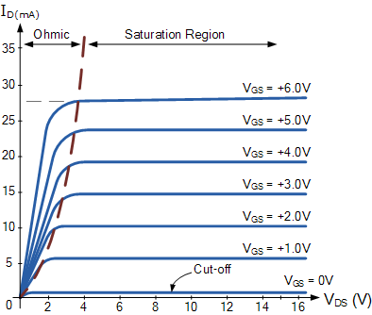
Your NMOS enhancement mode characteristic curves should look something like the graph on the left, but with different parameters
- Your “threshold voltage” will not be 0
- Your “Transconductance“ (I_{D}/V_{GS}) may be very high, so don’t overheat your MosFet (use small V_{GS} steps).
The polarities will be reversed for a PMOS device.
Warning: the PMOS symbol in Multisim is very confusing in all cases choose a MOS variant that explicitly shows a “Protection” Drain/Source diode that should always be reverse biased.
There is more about the structure and uses of a MosFet is in the next 2 experiments (5.5, 5.12) description.
Again, the PDFs included here relate to an earlier edition of your text so the chapter numbers, reference pages and figure numbers will not match those in your text.
