Lab 5.12 – A PMOS Source Follower
In this lab we are going to use a PMOS transistor (take care, the Multisim symbol for a PMOS device is confusing) and build a “Common Drain” amplifier (AKA a Source Follower). It is called a Source follower since that describes its behavior, the source (output) AC voltage is always approximately equal (there is a DC offset due to the Device threshold voltage) to the Gate AC voltage.
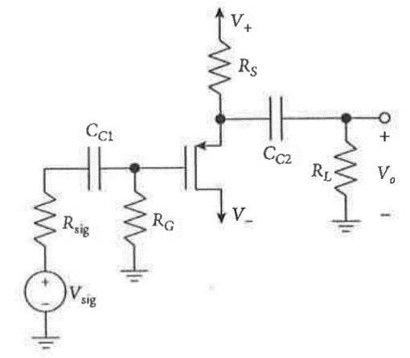
Notes:
- R_{sig} is the output impedance of the AC signal generator
which is 50 ohms for the function generator on our lab bench so do not put a physical source resistor in your actual circuit.
- The capacitors are there to block DC and at audio
frequencies should have a negligible reactance.
- V₊ and V₋ (15 volts) are ideally at AC ground

As with any design, you first select the resistors to put the transistor at a reasonable operating point. Then draw the AC (small signal) version of the circuit (capacitors are short circuits and the power rails are AC grounds and replace the PMOS device by a small signal model (see your Text) to calculate the voltage gain (approximately 1), input impedance (approximately R_{G}, and output impedance (very low – ignore R_{L}).
The source follower is an effective “Buffer Amplifier” to isolate your signal source from the load.
- It will not “load” the signal source (high input impedance)
- The output “follows” the input (unity voltage gain)
- The output voltage is almost independent of the load resistance (low output impedance)
Most of these characteristics are due to a high degree of negative feedback in this circuit. Note that the input to the transistor is V_{gs} which is the input voltage minus the output voltage and the feedback gain is high due to the transistor gain.
