Lab 6.12 – A PNP Emitter Follower
In this lab we are going to use a bipolar PNP transistor (A 2N3906 small signal PNP Transistor) and build a “Common Collector” amplifier (AKA an Emitter Follower). It is called a Emitter follower since that describes its behavior, the Emitter (output) AC voltage is always approximately equal (there is a DC offset due to the Device threshold voltage) to the Base AC voltage.
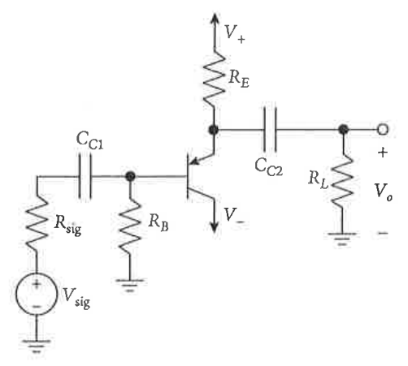
Notes:
- R_{sig} is the output impedance of the AC signal generator
which is 50 ohms for the function generator on our lab bench so do not put a physical source resistor in your actual circuit.
- The capacitors are there to block DC and at audio
frequencies should have a negligible reactance.
- V₊ and V₋ (15 volts) are ideally at AC ground
(often bypass capacitors are used to insure this)

As with any design, you first select the resistors to put the transistor at a reasonable operating point. Then draw the AC (small signal) version of the circuit (capacitors are short circuits and the power rails are AC grounds and replace the 2N3906 transistor by a small signal model (I prefer the current controlled current source model here) to calculate the voltage gain (approximately 1), input impedance (A bit less than R_{G}, and output impedance (very low – ignore R_{L}).
The Emitter Follower is an effective “Buffer Amplifier” that isolates your signal source from the load.
- It will not “load” the signal source (high input impedance)
- The output “follows” the input (unity voltage gain)
- The output voltage is almost independent of the load resistance (low output impedance)
Most of these characteristics are due to a high degree of negative feedback in this circuit. Note that the input to the transistor is V_{BE} which is the input voltage minus the output voltage and the feedback gain is high due to the transistor gain (Beta).
