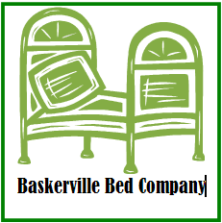
Baskerville Bed Company
5678 Greenlee Parkway
Franklin, OH 78655

Phone: 342-6544
Website: www.bbc.com

July 28, 2026

Recipient Here
Address Here
City, State, and Zip here

Dear Recipient Here:

We are looking forward to our next Board Meeting which will be held on the 15th of next month in the Crenshaw Hall. At that time board members will be given the opportunity to address questions about the status of the company. Because our latest line of mattresses is dong quite well, we thought it would be helpful to provide you with an advance view of the data.

The data you see here represents the sales data of the SS- line of mattresses. Notice that the mattress line is doing quite well. Following the data, we have provided a comparison of Sales and Cost for each mattress. Additionally we have provided a pie chart which shows the categories of cost.

Again, you will be given ample time to discuss this data at the board meeting. More detail pertaining to the board meeting will follow. In the meantime, feel free to give us a call should have questions about any of the material included in this mailing.

Sincerely,

Robert Eisley, President
Income Statement Data Here

Comparison Chart Here

Cost Pie Chart Here

