CS 107 SAM Tutorial Initialization
Dr. William R. Adams
input.doc
In order to access the SAM (Skills Assessment Manager) component of this course you MUST perform the following...

- Purchase the two (2) textbooks and the two (1) software packages from the bookstore.
The books are...
“Succeeding with Technology 2nd Edition – Computer System Concepts for Real Life”,
by Ralph M. Stair & Ken Baldauf, Thomson Course Technology
“New Perspectives – Office 2003, 1st course, 2nd Edition”
The software is...
SAM Computer Literacy
These are available as a packet at the bookstore.

Installing SAM Computer Literacy Software

- Install your SAM Computer Literacy software is optional as it is installed and available in the lab (Buckman 239). If you choose to do an install on your own PC, make certain that you have a lot of disk space remaining. In the past students have tried to install it an run out of disk space resulting in the need to reformat the hard drive and start installing all of you software and data (you do have backups, don’t you).
(Assessment and training for Microsoft Office 2003 and Computer Concepts)
- During the installation of this software you will be asked for your “Key Code” this is the 18 digit number which is printed on an orange label attached to you software. This Key Code is required to install the software and it will ONLY be useful ONCE! This Key Code CANNOT be shared! If you do not have a computer of your own, don’t worry. The department has installed the software on ALL computers in the computer labs indicated by your professor.
- The installed software is used in CONJUNCTION with the SAM web site. You MUST log onto the SAM web site in order to create a “User Profile”. This User Profile is VERY important, as it identifies you out of ALL users of Thomson Course Technology through the world. This user profile requires you to enter your Key Cod, even if you do not have your own computer.
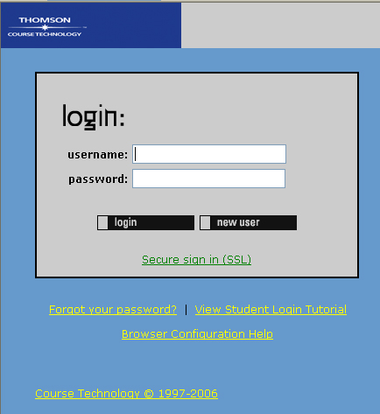
Logging on to the SAM web site:

- Navigate to...
sam2003.course.com
- You will see the screen to the right..............

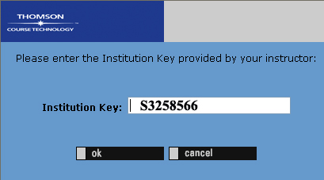
- Because you have NOT created a “username” and “password” account as yet you MUST select the <New User> button. This will bring you to the following screen.............................

8) On this screen you are to enter the “Institution Key” S3258566 and select “OK”

- The following response appears...
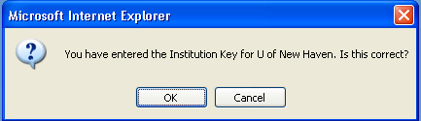
I’m using this as a “perfect BAD example” in my HCI class! NOTE: This dialog box asks “Is this correct?”, BUT it does NOT give you the Yes/No option!!!
Just select “OK” and you will see the screen below...

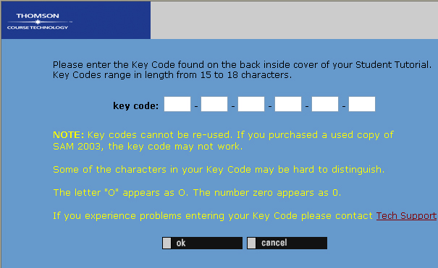
- This screen asks you to enter the “Key Code” which is printed on the orange sticker on your software. This Key Code will ONLY work for a SINGLE user. DO NOT try to share this code! Once you have entered this code you will be asked to enter some information to establish a “User Profile” at the Thomson Course Technology web site. This is a very important registration, as it will be the place where you will be submitting your “Component #2” assignments. This web site will be collecting and reporting to me, your grades.

